

Sergio Mateos

# **CS 465 Project Software Design Document**

Version 1.0

## Table of Contents

**CS 465 Project Software Design Document** 1

Table of Contents 2

Document Revision History 2

Instructions 2

Executive Summary 3

Design Constraints 3

System Architecture View 4

Component Diagram 4

## Document Revision History

| Version | Date | Author | Comments |
| --- | --- | --- | --- |
| 1.0 | 19 January 2023 | Sergio Mateos | Documented information about the functionality of Travlr Gateaway |

## Instructions

Web applications are complicated because of the complexity of the technology to support thousands of connections in a short time frame. The team is currently working on building a full web application for the client, Travlr Getaways. Maintaining the functionality and quality of the web application is very important. The Software Design Document (SDD) will contain technical specifications and descriptions of the Travlr Gateways web application.

## Executive Summary

The Travlr Gateway is a web application that is divided into index, user, and travel information. The users are available to see the picture of the destination, rooms, and meals. The users are available to access their information on the web application to make a reservation.

The Travlr Gateways web application would be developed by using the MEAN (MongoDB, Express, Angular, and Node) stack, MEAN is a JavaScript framework for developing web applications. The Travel Gateaways web applications require flexibility, scalability, and extensibility, that’s why the MEAN stack is the best option as the framework. On MEAN stack Node written on JavaScript would be the framework, MongoDB would be the database, Angular would be the client side and front end, and Express the webserver. Customers would be easy access to any part of the web application to maximize the convince of the customers. Since the Tralvr Gateways’ web application will use MongoDB, the data would be multidimensional which increases the performance.

The customer-facing side will allow them to search for travel, rooms, food, and everything that customers will need to have an amazing vacation. The Single-Page Application (SPA) reduce the amount of loading time, decrease the difficulty of development, and is more responsive, but it’s not well suited for large-scale application since the scalability is minimal.

## Design Constraints

The design constraints for developing the Travlr Getaway web application using MEAN are beneficial for the stability of the web application and will facilitate the change and updates. The high amount of traffic that the web application will have been easy to handle by using the MEAN stack. The web application requires compatibility with old and new web browsers and devices. The web application must implement proper security procedures, designed properly developed for the customer’s convenience, and quality size for different devices. Also, budget and timeline are crucial for a well-developed project. The failure of any of the last design constraints could lead to the failure of the project development.

## System Architecture View

### Component Diagram

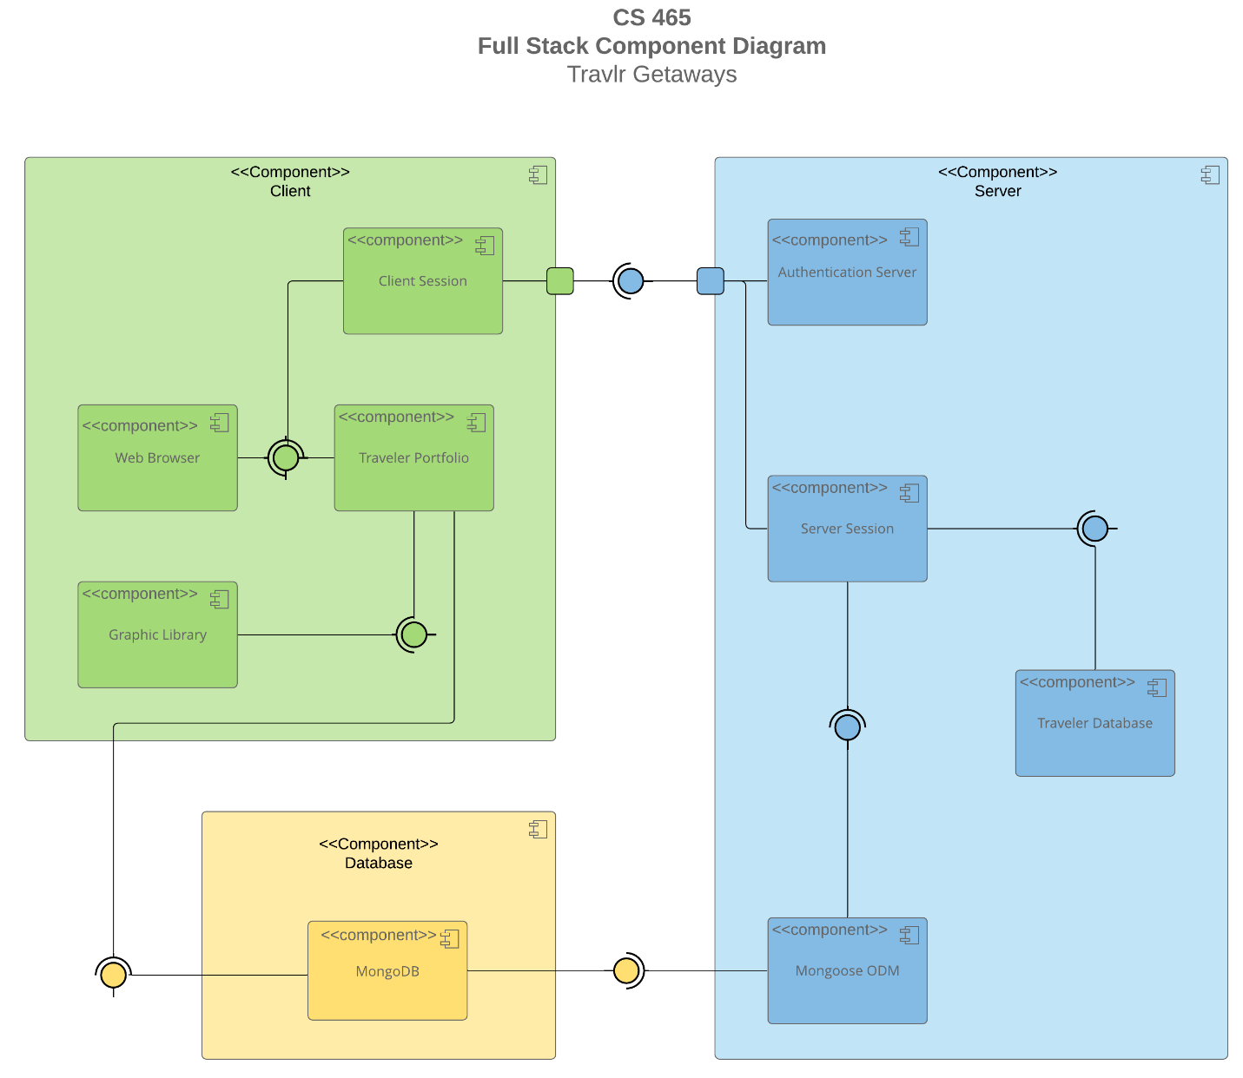

The Travlr Getaway web application will implicate three major components: Database, Client, and Server. The components would have their specific function and purposes:

* Client: The client components would start from the client session which along with the web browser will connect to the traveler portfolio. The images stored in the graphic library would be displayed in the web application.
* Database: The information would be stored on MongoDB, containing the information from the users and the web application.
* Server: Information will need to be validated before access to the site which would be authenticated in the authentication server, after the authentication is successfully passed it will allow the, to use the server session. The server session will connect to the Travel Database and Mongoose ODM which would export the information.

The connection would be in a loop and repeat, the customer will access content via web application where a web application will display and the customer will be able to interact. The Client would connect to the Database where the data and information would be stored and be able to export to the Server. The data would be analyzed and passed to display for the customer.